**CS423 DEVELOPMENT OPERATIONS**



**Assignment 3**

**TEAM:**

**Yousuf Rahman (2020520)**

**Zaeem Shakir (2020487)**

**Introduction:**

In this dynamic environment, automation plays a pivotal role in streamlining the software development lifecycle, ensuring efficiency, and enhancing collaboration among development and operations teams. This assignment delves into the implementation of a robust CI/CD pipeline for containerized applications, leveraging popular tools such as Docker and GitHub Actions. The focus is on automating the entire process, from development to deployment, across different environments, namely Development, Testing, Staging, and Production.

**Objective:**

The primary objective of this assignment is to empower DevOps engineers with the knowledge and skills to automate the software development and deployment pipeline. By extending the work initiated in a previous assignment, the teams are tasked with containerizing a ReactJS and NodeJS-based application, deploying it across multiple environments using Docker, and establishing a seamless CI/CD pipeline. This involves setting up EC2 instances on AWS for Development, Testing, and Staging environments, creating Docker files for each application component, and utilizing Docker Compose for orchestrating multi-container applications.

**Task 1:**

Devopsapp build:

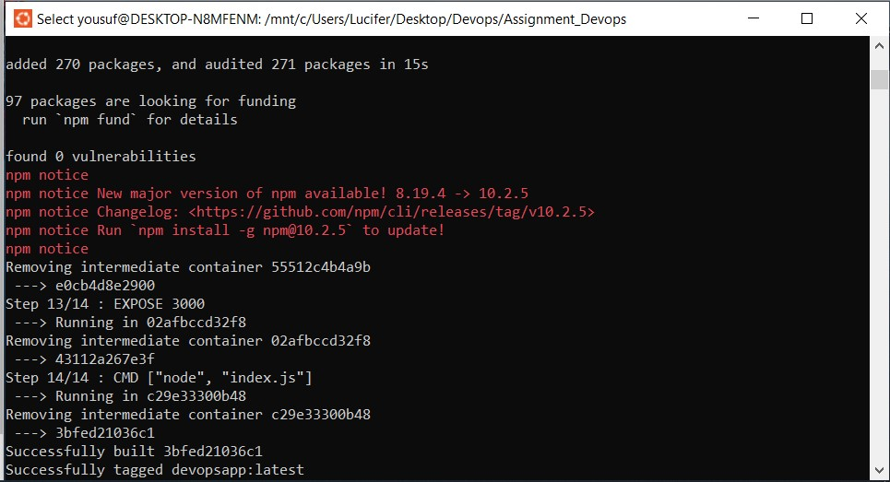

Docker-compose file:

Docker running on local host:

**Task 2:**

**Task 3:**

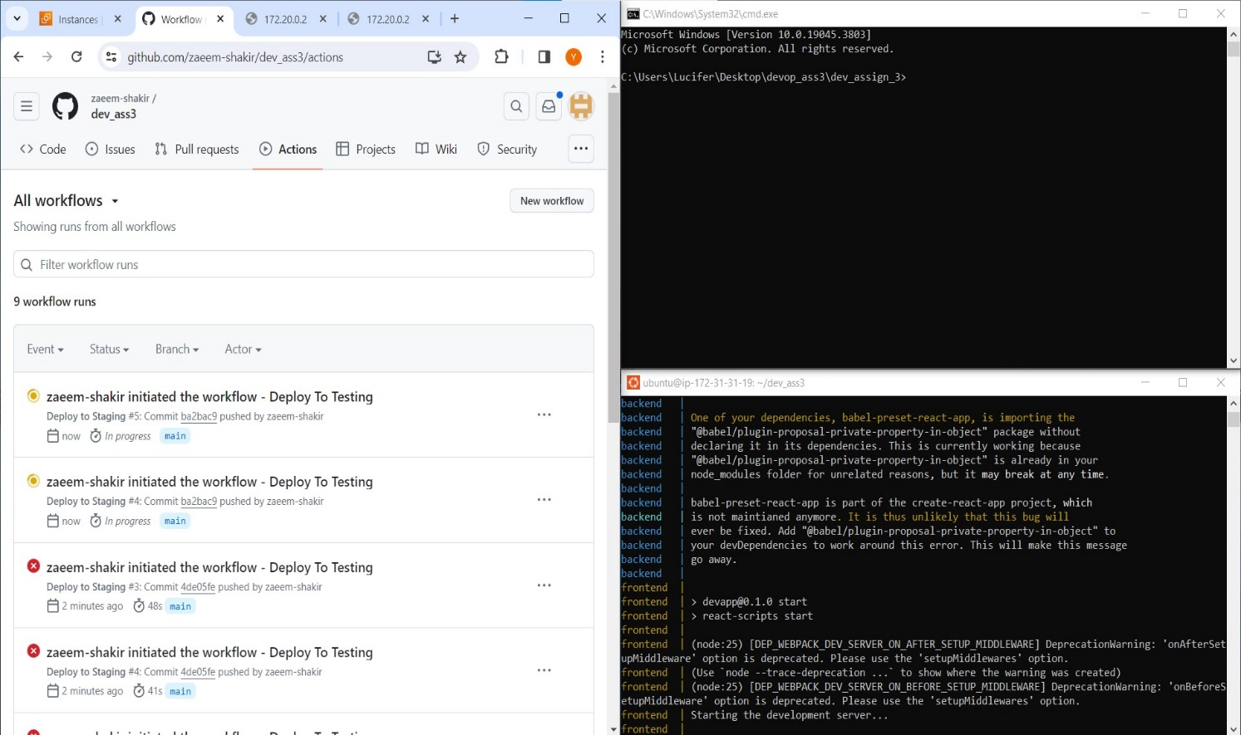

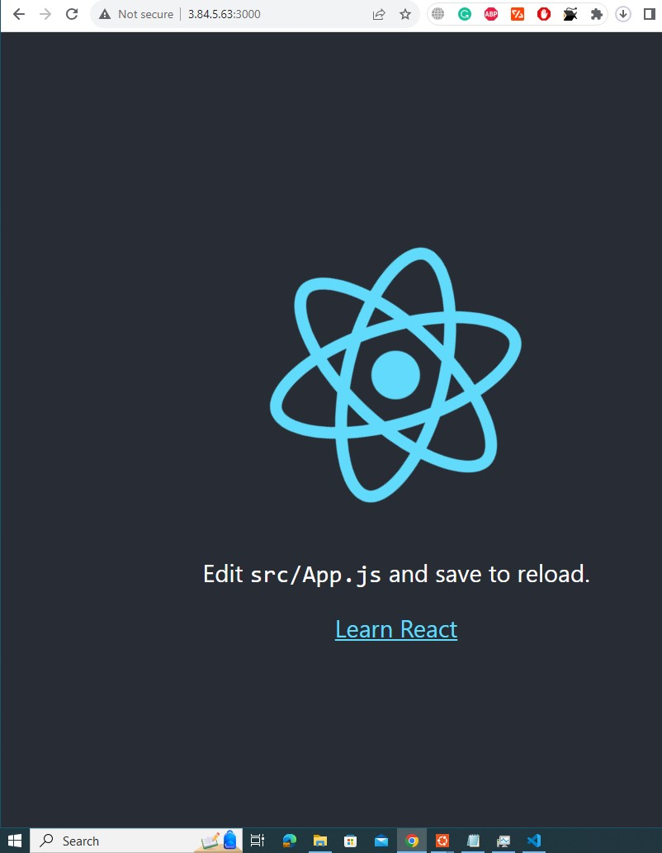

**GitHub Link:**

<https://github.com/zaeem-shakir/dev_ass3>

**Assignment 3 Instance Ip:**

51.20.138.55